

Integration of Microsoft RemoteDesktop WebAcess   
with DoubleClue using SAML2

# Introduction

This guide is intended for administrators who would like to use Multi-Factor Authentication (MFA) for Microsoft RemoteDesktop Web Access.

Requirements:

* Installation of Microsoft RD Web Access.
* DoubleClue Enterprise Management (DCEM) installation with readily registered users.

# Updating RDWeb

1. Make a backup of the installed directory windows/web/RDWeb
2. Extract the file “DC_RDWeb.zip” to the original directory

# Changing the Web.config

<sustainsys.saml2

entityId=”<http://dc02.doubleclue.local/RdWeb>” returnUrl="https://dc02.doubleclue.local/RDWeb"

discoveryServiceUrl=""  
authenticateRequestSigningBehavior="Always">

<nameIdPolicy allowCreate="true" format="Persistent" />

<requestedAuthnContext classRef="Password" comparison="Minimum" />

<identityProviders>

<add entityId=”https://DoubleClue.RDWeb" signOnUrl="http://hws001S0210.dom1.ad.tld:8002/dcem/saml" allowUnsolicitedAuthnResponse="true" binding="HttpRedirect">

<signingCertificate fileName="~/App_Data/idp_certificate.pem" />

</add>  
 </identityProviders>

<serviceCertificates>  
 <add fileName="~/App_Data/MyServerCertficate.pfx" /> </serviceCertificates>

</sustainsys.saml2>

1. Change the sustainsys.saml2/entityID to your Host name. I.E replace “dc02.doubleclue.local” with the URL where RDWeb is running
2. Replace also “dc02.doubleclue.local” for the returnUrl.
3. Replace the URL “hws001S0210.dom1.ad.tld:8002” with the host URL of your DoubleClue Enterprise Management (DCEM).
4. Now open the browser and go to <https://your-RD-Web-host/RDWeb/Saml2/> . A file will be downloaded. Save this file, as we will need this in the next step.

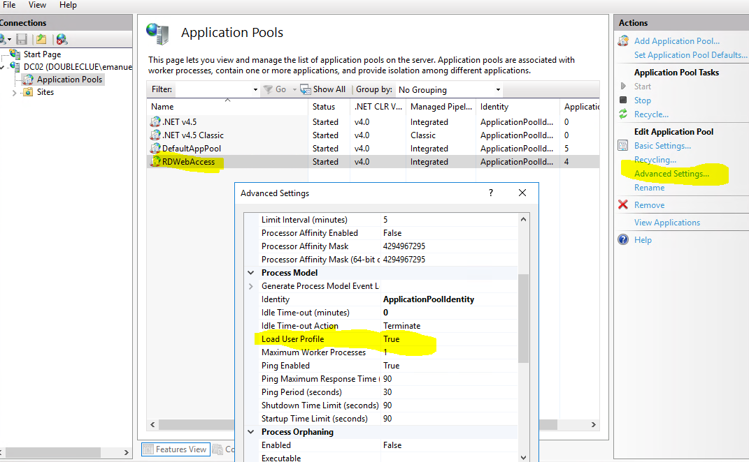

# Configuration in DoubleClue Enterprise Management (DCEM)

1. Go to menu “SAML->SP Metadata” and click on “Add”.
2. Select Custom as SP Configuration
3. Enter a “Display Name” and upload the file which you downloaded from “<https://your-RD-Web-host/RDWeb/Saml2/>”
4. Go to Tab “Details” and specify the “Expected NamedID Format” to “ENTITY”.
5. In menu “SAML->SP Metadata” click on “Downlaod Idp Metadata” and the click on “Download Certificate”.
6. Copy this file to your RDWeb host in the directory “RDWeb/App_Data” and in “RDWeb/Pages/App_Data”.

# Procedure

To use RDWeb, users enter the URL https:// your-RD-Web-host /RDWeb/Pages. This will be automatically redirected to the DCEM SAML login page. User will do the authentication and will be redirected to the RDWeb launching page.